
Glossary of Terms

SCHOOL ADMISSIONS POLICY 2025/2026
For
All Community and Voluntary Controlled Schools

Victoria Schofield

Corporate Director
Children and Young People
WAKEFIELD COUNCIL
CHILDREN AND YOUNG PEOPLE SERVICE

Glossary of Terms

  - “the LA” means Wakefield Metropolitan District Council acting in its capacity as local authority.

  - “the LA area” means the area in respect of which is the local authority.

  - “school” means a community school, or voluntary controlled school. Community special schools are not covered by the policy.

  - “specified year” means the school year beginning at or around the beginning of September2025.

  - “admission authority” in relation to a community or voluntary controlled school means the LA. The governing body of foundation (trust) and aided schools are the admission authorities for those schools. The Secretary of State is the admission authority for Academies.

  - “admission arrangements” means the arrangements for a particular school or schools which govern the procedures and the decision making for the purposes of admitting pupils to the school.

Admissions to Community and Voluntary Controlled Schools

2.1 The Policy on admissions to community and voluntary controlled schools are determined by the Council following consultation with governing bodies. The administration of admissions is the responsibility of the School Admissions Team within the Children and Young People Service.

Expressing a Preference

3.1 In the case of applications for admission to Reception, Year 3 at a Junior School or Year 7 within the Wakefield area, applications from Wakefield residents should be made on Wakefield’s Common Application Form.

3.2 Attendance at a nursery unit or nursery class/co-located children’s centre attached to a primary/infant school below compulsory school age does not guarantee a place at that school. Applications for a part time place in a nursery unit or nursery class/co-located children’s centre attached to a primary/infant school must be made to the school or centre and are covered by the school’s separate part-time admissions policy.

3.3 All applications for a school place in the Wakefield district must be made in line with the requirements of the relevant Co-ordination Scheme and will be processed in accordance with this admissions policy.

3.4 Applications for Reception, Year 3 at a Junior School or Year 7 from residents outside the Wakefield District should be made in accordance with the applicant’s “home” LA’s Common Application Form.

3.5 Repeat applications made for entry to the same oversubscribed year group at the same school will not be considered unless there has been a material change in circumstances since the original application. School Admissions will determine if there has been a material change in circumstances. Examples of a material change include a change of address. Where information was known at the time of the original application, or appeal, but parents chose not to use it, this information will not be considered as additional information or a change of circumstances.

3.6 Wakefield LA operates waiting lists for every year group for the whole of the school year until the end of the summer term in July and where a place becomes available in the relevant year group the place is offered to the child who is at the top of the waiting list. Any parent wishing to be placed on the waiting list for the subsequent academic year will have to re-apply for that academic year.

3.7 Where parents submit a Common Application Form under a Co-ordinated Admissions Scheme, whether in the normal admissions round or in-year, which names more than one community or voluntary controlled school, all applications will be treated equally and eligibility for a school place will be decided in accordance with this Admissions Policy.

The Admissions Policy

4.1 If the number of preferences received for a school does not exceed the Admission number, all preferences will be met (see explanatory note 16.1).

4.2 All applications received will be considered in the following order:

- Applications received by the closing date in the normal admissions round:

- for secondary applications the closing date is 31 October 2024; and
- for primary applications the closing date is 15 January 2025.

- For late applications received between the closing date for the normal admissions round and the end of the summer term the following dates will apply:

- Applications for secondary places received up to and including 20 November 2024 will be accepted as if they had been received by the closing date;
- Applications for primary places received up to and including 14 February 2025 will be accepted as if they had been received by the closing date.
- Applications received after these dates will be regarded as late applications and will be considered after all applications received on time

4.3 If there are more applications for admission to a school than there are places available, preference will be given in the following order:

- (i) Looked after Children, all previously Looked after Children and Children who appear (to the admission authority) to have been in state care outside of England and ceased to be in care as a result of being adopted.

This refers to children who are:

- Subject to a care order made by the courts under section 31 of the Children Act 1989 – for the courts to grant a care order they have to be satisfied that a child is suffering or would suffer ‘significant harm’ without one;
- Children who are accommodated by the Local Authority on a voluntary basis under Section 20 of the Children Act 1989;
- Children who have been adopted from Local Authority care, children who are subject to a Child Arrangements Order and those with special guardianship immediately following being Looked After will all be included within the higher priority for Looked after Children;
- A child is regarded as having been in state care outside of England if they were in the care of or were accommodated by a public authority, a religious organisation, or any other provider of care whose sole or main purpose is to benefit society (see section 23ZZA (8) of the Children Act 1989 (inserted by section 4 of the Children and Social Work Act 2017) (see explanatory note 16.2);

- (i) Children who live in the school’s catchment area, who have brothers or sisters attending the school at the time of admission (see explanatory note 16.3);

(ii) Other children who live in the school’s catchment area (see explanatory note 16.4);

- Children who have brothers or sisters in attendance at the school (see explanatory note 16.3);

- Other children, with priority being given to those living nearest to the school (see explanatory note 16.5).

4.4 In all categories “live” means the child’s permanent home address. A child is normally regarded as living with a parent or carer and the LA will use the parent or carer’s address for admission purposes. Where an address is given which is either not the address of the child’s parent or carer or is not the child’s true home address, that address will not be treated as the home address for the purposes of the application. Where the LA becomes aware that a child is living temporarily with someone other than his/her parent or carer and has moved there for the sole purpose of gaining a place at a particular school, and the address of that person has been given as the home address in the application, the application will be treated as intentionally misleading or fraudulent and the school place offered may be withdrawn (see explanatory note 16.6).

4.5 Only one address can be used on the application for a school place. Where shared care arrangements are in place, both parents must agree which address will be used on the application, and this should be the address where the child lives for the majority of the school week. If no joint declaration is received by the closing date for applications, the local authority will determine which address will be used, based on where the child spends the majority of the school week. In instances where the child spends equal time with each parent, the home address will be taken as the address where the child is registered with the doctor (see explanatory note 16.6).

4.6 By submitting an application for a school place, the parent is confirming that they have parental responsibility for the child named on the form, or if parental responsibility is shared, that both parents are in agreement regarding the preferences stated on the application for a school place. In the case of parents disagreeing on the schools preferred, there is an expectation that parents will resolve these disputes themselves and make a single application which both parents are in agreement with (see explanatory note 16.7).

4.7 In all categories, when decisions have to be made between children satisfying the same criterion, children living nearest to the school, measured as the crow flies, have priority. The distance will be measured using the National Land and Property Gazeteer (NLPG).

4.8 Where there is more than one application from a postal address contained within a block of flats, places will be decided by random allocation.

If two or more pupils live equidistant from the school, the distance each pupil lives by road from the preferred school will be measured and the place offered to the pupil who lives nearest by this means. In the event of this being equal, places will then be decided by random allocation.

4.9 Where the admission of siblings from a multiple birth (eg twins, triplets) would cause the school to rise above its Planned Admission Number (PAN), all of the children from the multiple birth will be admitted.

4.10 In the case of infant classes, where the admission of the children from a multiple birth would result in the PAN rising above 30 (or multiples of 30), the additional child/children will be regarded as an ‘exception’ to the Infant Class Size legislation throughout the infant phase or until the number in the year group reduces to the PAN.

4.11 Children will be placed in the appropriate category depending upon their circumstances at the closing date for receiving applications for admission to school. Changes in address will be accepted in accordance with the provisions of the Secondary and Primary Co-ordination Schemes. In cases where there is an anticipated change in circumstances, documentary evidence will be required.

In the event of any school being over-subscribed, places will be offered in the order of priority (a) – (d) detailed above.

Children with and Education Health and Care Plan

5.1 Children with identified Special Educational Needs have a significantly greater difficulty learning than their peers and/or cannot access learning without significant adaptations to the school facilities. This typically means that additional support will be required for them in order to access learning. Further information can be obtained from the SEND Code of Practice (January 2015), Special Educational Needs Assessment and Review Team (SENART) or the Special Educational Needs and Disability Information and Support Services (SENDIASS).

5.2 Admission authorities:

- Must consider applications from parents of children who have special educational needs or disability (SEND) but do not have an Education, Health and Care Plan (EHCP) on the basis of the published admissions criteria as part of the normal admissions procedures;
- Must not refuse to admit a child who has SEND but does not have an EHC Plan because they do not feel able to cater for those needs;
- Must not refuse to admit a child on the grounds that they do not have an EHC Plan;
- Must not discriminate against any child or young person who has an SEN or disability and must make reasonable adjustments as set out in the Equalities Act (2010) so that they can be admitted to the school where they do not have an EHC Plan.

5.3 Children with an Education, Health and Care Plan (EHCP) are dealt with under a different mechanism. Any child with a school named on their EHC Plan will automatically gain a place at the school named via the statementing process. Any child with an EHC Plan who is admitted to a mainstream community/voluntary controlled school will be counted against the school’s admission number.

The Offer of a School Place at School

6.1 Decisions will be posted 2nd class to parents who made a paper application on the following days:

Secondary schools : 3 March 2025
Primary, infant & junior schools : 16 April 2025

6.2 Parents who made an online application will be able to access their offer of a school place via the on-line website after 00:00 on the respective offer date. A confirmation email will also be sent to the registered email address on the respective National Offer Day.

Point of Entry

7.1 All pupils will start in the in-take year (ie Y7 for secondary schools, Y3 for junior schools and Yr R for infant/primary schools) on the first day the school is open following 1 September 2025.

  - These arrangements do not apply to those pupils applying for nursery provision including nursery provision in a co-located children’s centre (see explanatory note 16.8).

Deferred Entry to Primary Schools

8.1 Where the LA offers a place at a primary or infant school, a parent who accepts that school place can defer entry to that school until the term after the child’s fifth birthday. There may be spring and summer term admissions as a result of parents who have deferred their child’s entry.

8.2 Any deferred place at the school will be held for that child and will not be available to be offered to another child and the deferred place must be taken up during the same school year for which the offer of the school place was made and accepted. Parents cannot defer entry to a school to the next academic year or beyond the beginning of the term following the child’s fifth birthday, these types of requests are dealt with under section 9 below.

8.3 Parents can also request that their child attends school part-time instead of full-time until the child reaches statutory school age.

Admission of Children Outside their Normal Age Group

9.1 Parents can seek school places outside their child’s normal age group. Parents must make an application for their child’s normal age group at the usual time however a separate request must also be made at the same time for admission out of the normal age group.

9.2 Parents of ‘summer born children’ (ie those children born between 1 April and 31 August) may choose not to send their child to school until the September following the child’s fifth birthday and may request that they are admitted into reception rather than year 1. This would mean that the child is being educated outside their normal age group (see explanatory note 16.9).

9.3 Where such a request is made, the Local Authority will make a decision on the basis of the circumstances of the case and in the best interest of the child concerned, taking into account the views of the head teacher and any supporting evidence provided by the parent (see explanatory note 16.9).

9.4 Where a decision is to refuse the request there is no right of appeal if the child is offered a place in another year group in the school.

Unsuccessful Applications

10.1 If a Wakefield pupil is not successful in securing a place at any school he/she has preferenced a school place will be allocated in accordance with the Wakefield Co-ordinated Admission Arrangement Scheme.

10.2 Any parent whose child is not offered a school place for which they have expressed a preference has the right to appeal to an independent appeal panel.

Waiting lists

11.1 Pupils will be added to the waiting lists of community and voluntary controlled schools where they were refused a place in accordance with the provisions of either the Primary or Secondary Co-ordination Schemes or In-Year Co-ordination Schemes.

11.2 Places will be allocated from the waiting list when the number of pupils in the relevant year group falls below the admission number for that school. Waiting lists will be kept in strict priority order against the oversubscription criteria above.

11.3 The waiting list for each school will be reviewed and revised each time a child is added to or removed from the waiting list and/or when a child’s changed circumstances will affect their order of priority for a school place.

11.4 The waiting list will be established on the offer day and will be maintained up to and including the end of the summer term in July2026. Any parent wishing to be placed on the waiting list for the subsequent year group will have to re-apply for that academic year.

In-Year Admissions

12.1 All applications made outside the normal admissions round (i.e. in-year applications) for community and voluntary controlled schools should be made on Wakefield’s Common Application Form, which is available from the School Admissions Team. Applications will be processed in accordance with the “In-Year Co-ordination Scheme”. Parents can express up to 5 school preferences.

12.2 Where there are sufficient places, an application will normally be agreed. The admission number for a school is set for the school’s in-take year. As a general rule, this admission number then remains with that year group as it moves through the school. There may be exceptions, for example, if accommodation in a school is removed, then the admission number may change for subsequent year groups.

12.3 If a place is not available, a refusal letter is sent outlining the right of appeal. If the application is from a Wakefield resident then a place will be allocated at the next nearest community and voluntary controlled school with places. If the child is already attending a Wakefield school and/or there is no change of address since the previous application, an alternative school will not be offered. The child’s name will be added to the waiting list for the school in order against the over-subscription criteria in section 4.3 above. All waiting lists are re-ranked when new applicants have been added. Should a vacancy arise at the school, the place will be offered to the child at the top of the waiting list.

If a place cannot be offered at a preferred school, and the address is not in Wakefield, the home authority will be responsible for allocating an alternative school.

Fair Access Protocol

13.1 The LA has agreed a Fair Access Protocol for qualifying in-year applications with its primary and secondary schools. This means that, in some circumstances, pupils defined in the Protocol will have a higher priority for admission to schools and/or year groups, which are already full, than all other pupils seeking admission to the school. Full details of the Protocol can be obtained from the LA.

6th Form Applications

14.1 All schools and academies with sixth form provision are required to publish a separate admissions policy for entry into Year 12.

14.2 Applications for admission to the sixth form, including pupils currently attending the school must be made via the online prospectus and common application process (www.ucasprogress.com)

14.3 A pupil will only be admitted to the sixth form of a school provided they meet the sixth form admission criteria of the school preferred.

False Information

15.1 Where the LA has made an offer of a place at a school on the basis of a fraudulent or intentionally misleading application from a parent which has effectively denied a place to a child with a stronger claim to a place at the school, the offer of a place may be withdrawn.

15.2 Where a child starts attending the school on the basis of fraudulent or intentionally misleading information the place may be withdrawn depending on the length of time that the child has been at school.

15.3 Where a place or an offer has been withdrawn the parent will be asked to submit a new application form. This new application form will then be considered afresh against the relevant admissions policy and co-ordination scheme.

15.4 It is for the parents or guardian to satisfy the LA of their circumstances, as they apply to the admission criteria at the time of the application.

Explanatory Notes

16.1 Admissions Numbers
Each maintained school has a Published Admission Number (or PAN) for each “relevant age” group. Every year, the LA consults with the Governing Body of the school before the Admission Number is set. In the case of year of entry (ie Year 7, Year 3 or Year R), a child may not normally be refused admission to a school unless the number of applications for admission exceeds the admission number, or a child is offered a school which is ranked higher on the Common Application Form under the respective Co-ordinated Admissions Policy.

16.2 Looked after Children and previously Looked after Children
A ‘looked after child’ is a child who is (a) in the care of a local authority, or (b) being provided with accommodation by a local authority in the exercise of their social services functions (see the definition in Section 22(1) of the Children Act 1989) at the time of making an application to a school.

A ‘previously looked after child’ includes children who were adopted (from Local Authority care) under the Adoption Act 1976 (see section 12 adoption orders) and children who were adopted under the Adoption and Children’s Act 2002 (see section 46 adoption orders).

Children who were previously looked after includes children who have been adopted from Local Authority care, or who are subject to a Child Arrangements Order and those with special guardianship immediately following being in care.

Child Arrangement Orders are defined in s.8 of the Children Act 1989, as amended by s.12 of the Children and Families Act 2014. Child arrangements orders replace residence orders and any residence order in force prior to 22 April 2014 is deemed to be a child arrangements order.

See Section 14A of the Children Act 1989 which defines a ‘special guardianship order’ as an order appointing one or more individuals to be a child’s special guardian (or special guardians).

A child is regarded as having been in state care outside of England if they were in the care of or were accommodated by a public authority, a religious organisation, or any other provider of care whose sole or main purpose is to benefit society (see section 23ZZA (8) of the Children Act 1989 (inserted by section 4 of the Children and Social Work Act 2017).

16.3 Brothers and Sisters
This category includes children with brothers or sisters (including step-brothers or step-sisters residing at the same address) of statutory school age, living at the same address, in attendance at the same school, or a school on the same site, on the date of admission.

16.4 Catchment Areas
The LA believes it is important that schools should serve their local communities and so each one has its own catchment area. However, parents are required to express a preference, stating their choice of school, even if this is within their catchment area.

Whilst every effort is made to ensure that there will be a place for every child in its catchment area school, it cannot be guaranteed that this will always be the case.

If parents are in any doubt about the catchment area school for the area in which they live, they need to contact their local school or the School Admissions Team. Further information is also available in the Secondary and Primary Guides for Parents.

The home addresses of some pupils may fall into an area that forms part of the catchment area of two schools (this is known as an Option area). Where a pupil’s address falls within two catchment areas, the LA will consider the application as children who live in the catchment area for both schools.

16.5 Families living outside the District boundary
Children from families living outside the Wakefield Metropolitan District boundary will be considered alongside those who live within the Wakefield Metropolitan District.

16.6 Address
The LA investigates all queries about addresses and an offer may be withdrawn where the LA concludes that the parent/carer has made a fraudulent or deliberately misleading application.

When an offer is made, it is assumed the parental address will be the same in the following September as is held on the LA’s records. If a parent plans to move or has moved house, the parent must let us know immediately as the date of the move could affect the address which is considered to be the home address for the purposes of the application.

For secondary places, any change of address received after 06 January 2025 will be used for correspondence purposes only and will not be administered until after the secondary National Offer Day. Until then the application will continue to be processed from the last known address.

For primary places, any change of address received after 01 March 2025 will be used for correspondence purposes only and will not be administered until after the primary National Offer Day. Until then the application will continue to be processed from the last known address.

Where a parent fails to notify the LA of a change of address, this may lead to the application being treated as a fraudulent or misleading application. This in turn may lead to the place, or offer of a place, being withdrawn. Where the place is withdrawn, the LA will offer a place at the next nearest school to the new home address which has a place available.

16.7 Parental Disputes
Parental Responsibility gives both parents important legal rights as well as responsibilities to be involved in decisions such as the choice of school. The LA can only process one application per child which has been made by a person who has parental responsibility for that child.

Where the LA receives two conflicting applications both made by persons who have parental responsibility, the LA cannot process either application and the parents must decide between them which application will be withdrawn. Evidence of parental responsibility must be provided.

If an agreement is reached after the respective National Offer Day the agreed preferences will be processed as a late application.

Where an application has been made by a parent who has parental responsibility, and the other parent advises the LA that he/she disagrees with the school preference, the LA will continue to process the original application unless the parent who disagrees with the school preference provides evidence that the applicant does not have parental responsibility for the child, or is otherwise prevented from determining which school the child should attend. Such evidence would be a copy of an existing Court Order or a Specific Issues Order.

16.8 Points of Entry
Parents of children who are admitted for nursery provision must apply for a place at the school if they want their child to transfer to Reception class.

Attendance at nursery does not guarantee admission to school.

16.9 Deferment for summer born children
If the child’s 5th birthday is between 1 April and 31 August, then they must start school no later than the following September. Parents of summer born children are currently able to request that their child defer entry to a reception class for a full academic year.

If the request is allowed, normal admission rules will apply and there is no guarantee that a place will be offered at the requested school(s).

Parents should set out their reasons for their request in writing to the School Admissions Team, Wakefield One, PO Box 700, Wakefield, WF1 2EB during the autumn term after their third birthday. This will ensure that they do not miss out on a place at the normal point of entry. Such requests should be made by the closing date – 14 February 2025.

Version No: | Date Ratified: | Review Date:
1.0 | 21.2.24 | October 2024

Catchment Area Maps

It is not possible to represent the full detail of the catchment areas on this visual map. You can look up your individual address to check for catchment priority on Wakefield Council’s website https://www.wakefield.gov.uk/schools-and-children/schools/school-catchment-area-search

Airedale Pyramid

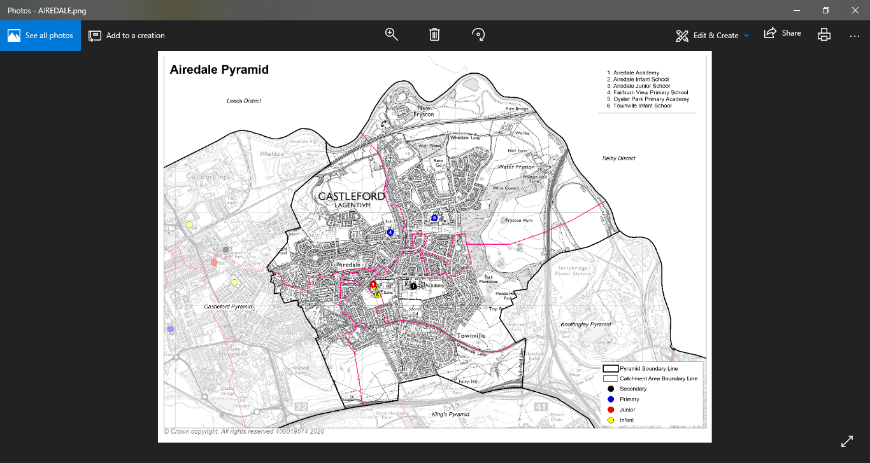

It is not possible to represent the full detail of the catchment areas on this visual map. You can look up your individual address to check for catchment priority on Wakefield Council’s website https://www.wakefield.gov.uk/schools-and-children/schools/school-catchment-area-search

Carelton & Kings Pyramid

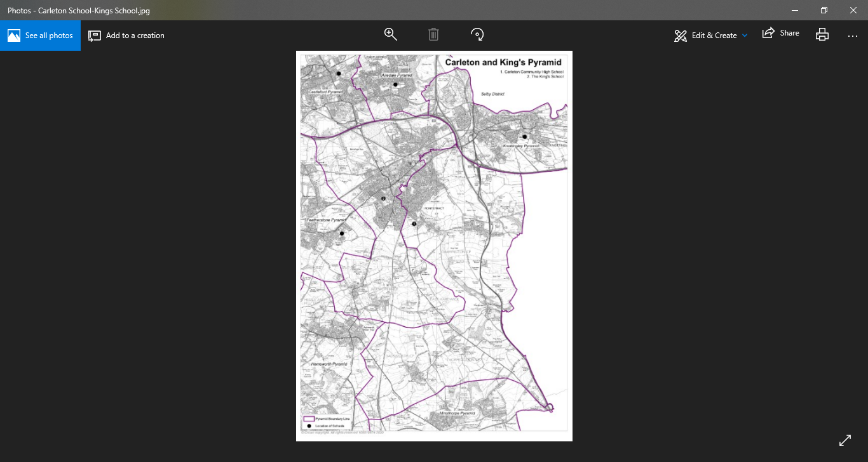

It is not possible to represent the full detail of the catchment areas on this visual map. You can look up your individual address to check for catchment priority on Wakefield Council’s website https://www.wakefield.gov.uk/schools-and-children/schools/school-catchment-area-search

Castleford Pyramid

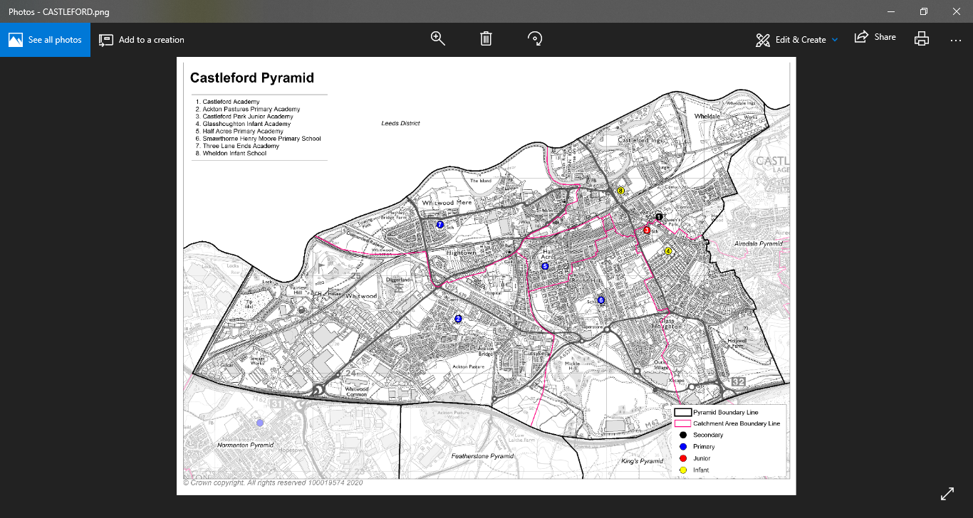

It is not possible to represent the full detail of the catchment areas on this visual map. You can look up your individual address to check for catchment priority on Wakefield Council’s website https://www.wakefield.gov.uk/schools-and-children/schools/school-catchment-area-search

Cathedral Pyramid

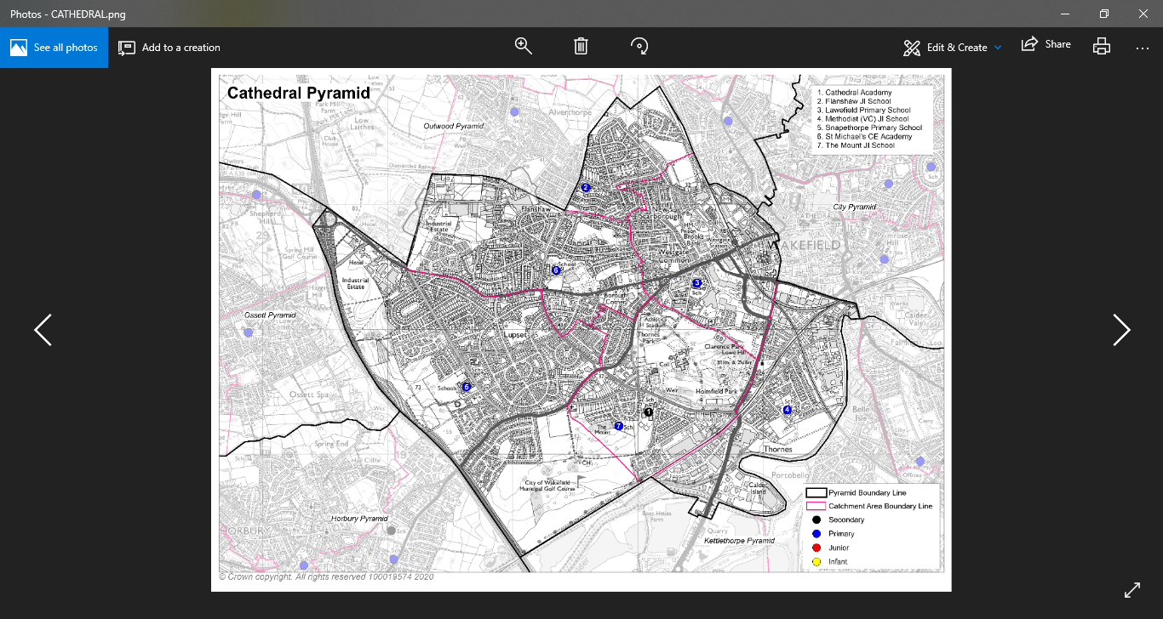
It is not possible to represent the full detail of the catchment areas on this visual map. You can look up your individual address to check for catchment priority on Wakefield Council’s website https://www.wakefield.gov.uk/schools-and-children/schools/school-catchment-area-search

City Pyramid

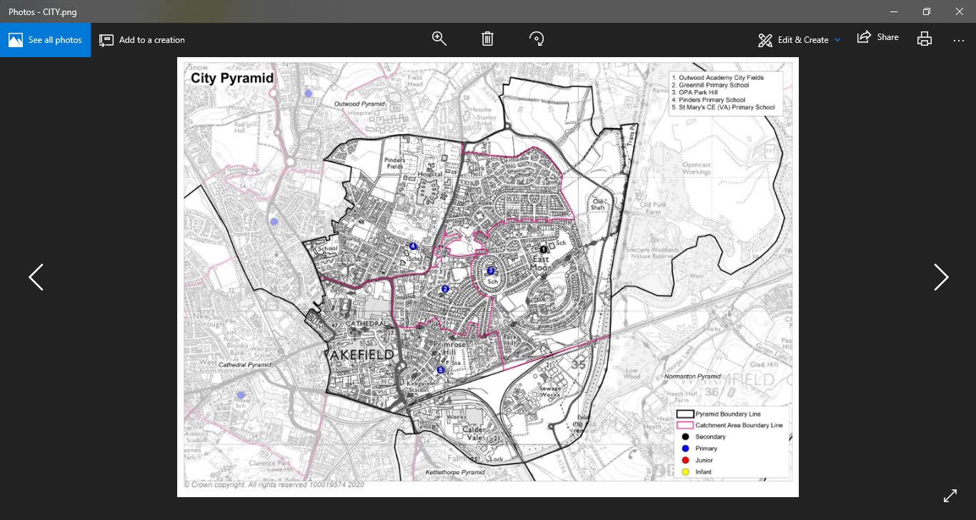

It is not possible to represent the full detail of the catchment areas on this visual map. You can look up your individual address to check for catchment priority on Wakefield Council’s website https://www.wakefield.gov.uk/schools-and-children/schools/school-catchment-area-search

Crofton Pyramid

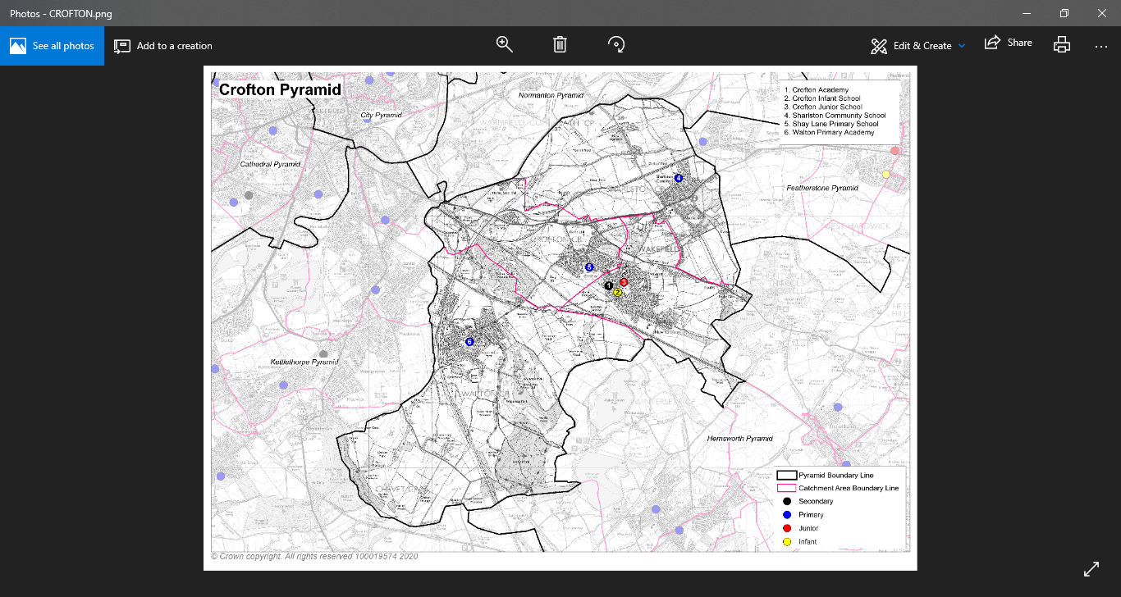

It is not possible to represent the full detail of the catchment areas on this visual map. You can look up your individual address to check for catchment priority on Wakefield Council’s website https://www.wakefield.gov.uk/schools-and-children/schools/school-catchment-area-search

Featherstone Pyramid

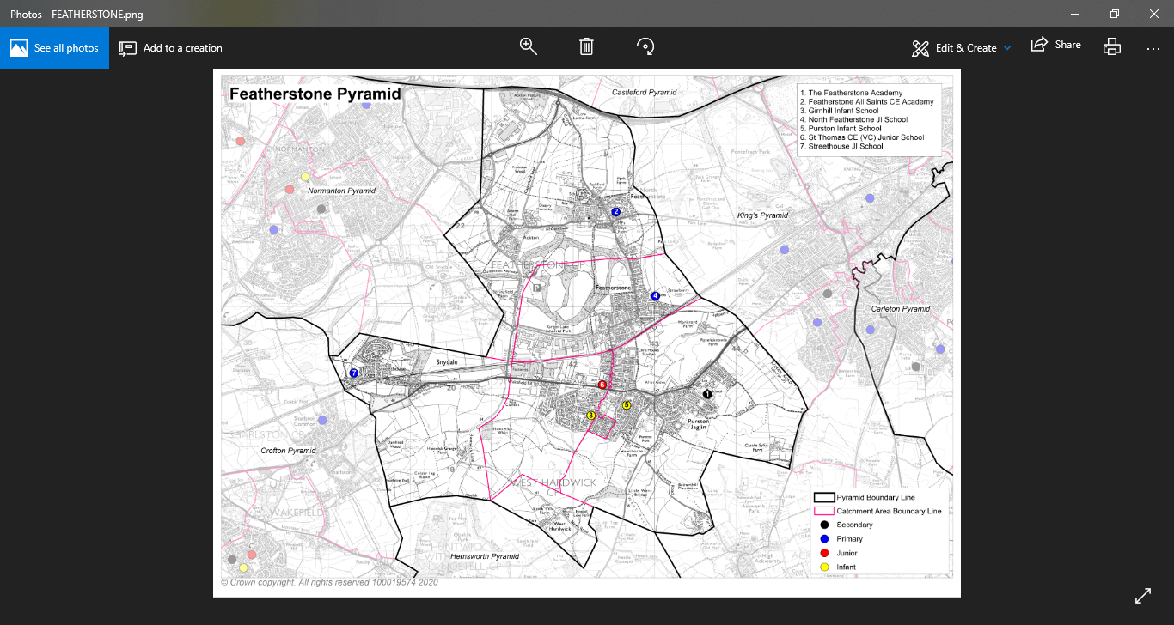
It is not possible to represent the full detail of the catchment areas on this visual map. You can look up your individual address to check for catchment priority on Wakefield Council’s website https://www.wakefield.gov.uk/schools-and-children/schools/school-catchment-area-search

Hemsworth Pyramid

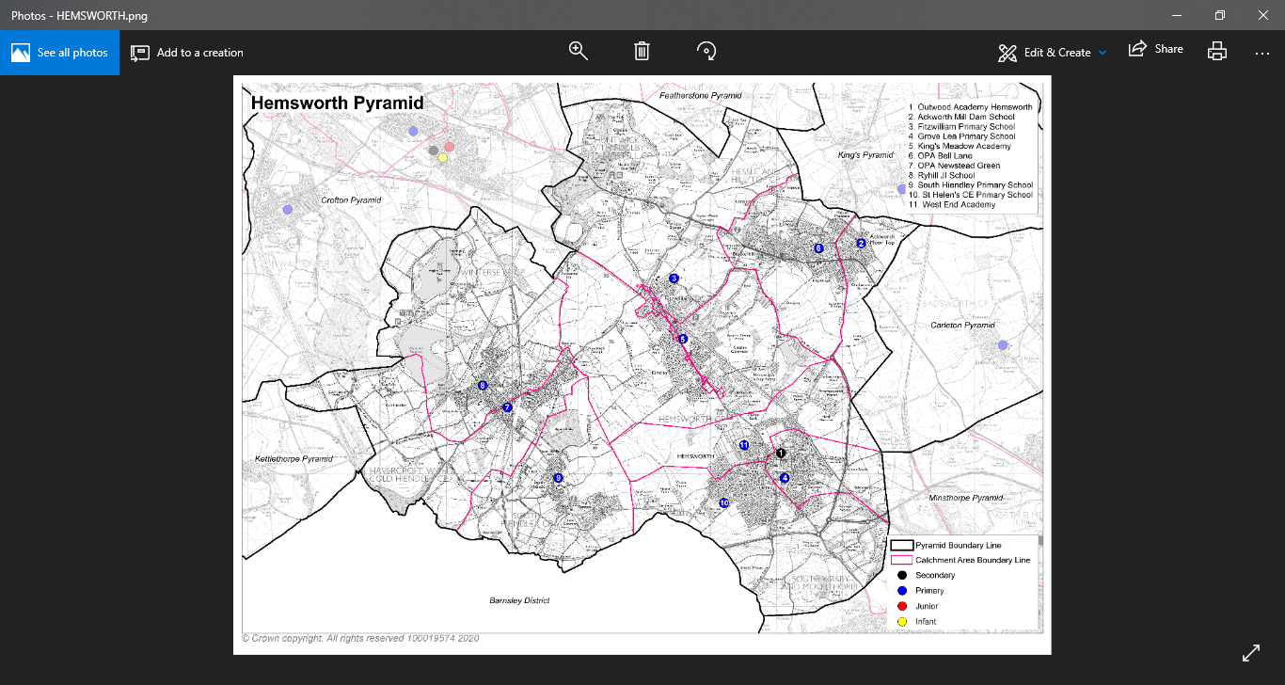

It is not possible to represent the full detail of the catchment areas on this visual map. You can look up your individual address to check for catchment priority on Wakefield Council’s website https://www.wakefield.gov.uk/schools-and-children/schools/school-catchment-area-search

Horbury Pyramid

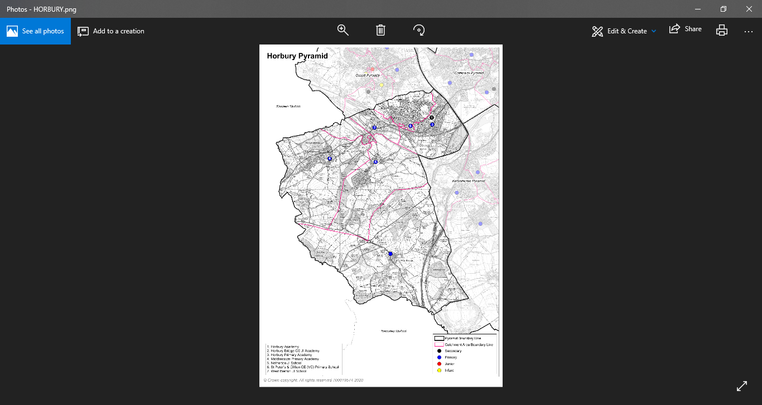
It is not possible to represent the full detail of the catchment areas on this visual map. You can look up your individual address to check for catchment priority on Wakefield Council’s website https://www.wakefield.gov.uk/schools-and-children/schools/school-catchment-area-search

Kettlethorpe Pyramid

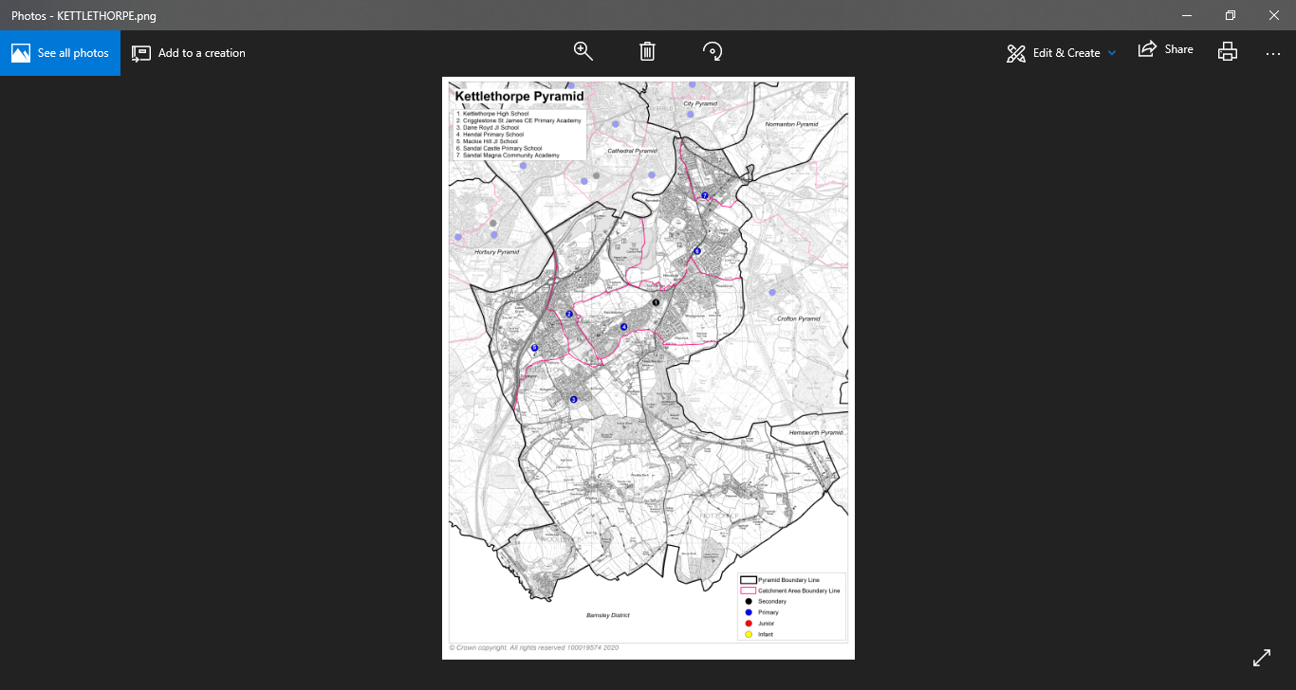
It is not possible to represent the full detail of the catchment areas on this visual map. You can look up your individual address to check for catchment priority on Wakefield Council’s website https://www.wakefield.gov.uk/schools-and-children/schools/school-catchment-area-search

King’s Pyramid

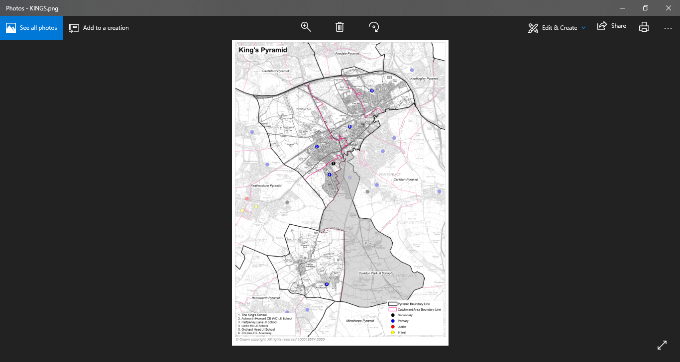

It is not possible to represent the full detail of the catchment areas on this visual map. You can look up your individual address to check for catchment priority on Wakefield Council’s website https://www.wakefield.gov.uk/schools-and-children/schools/school-catchment-area-search

Knottingley Pyramid

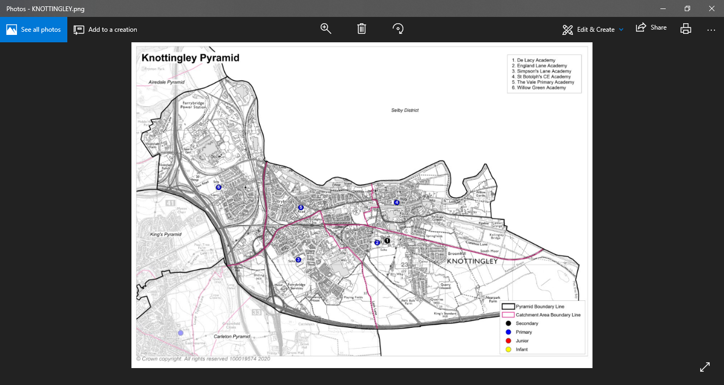
It is not possible to represent the full detail of the catchment areas on this visual map. You can look up your individual address to check for catchment priority on Wakefield Council’s website https://www.wakefield.gov.uk/schools-and-children/schools/school-catchment-area-search

Minsthorpe Pyramid

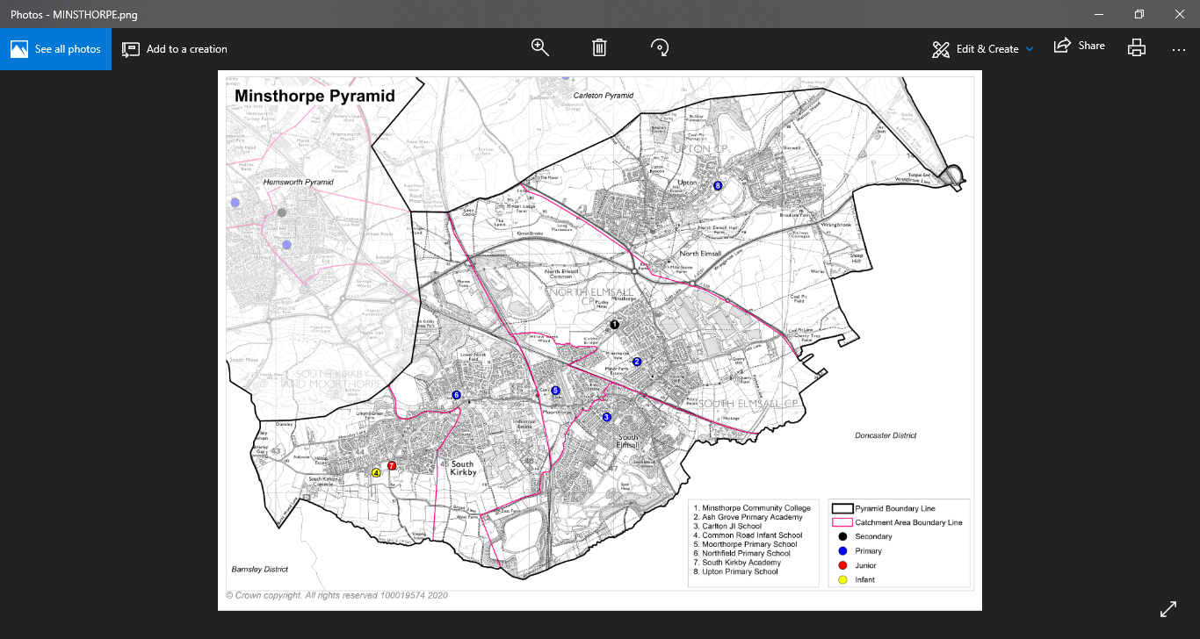

It is not possible to represent the full detail of the catchment areas on this visual map. You can look up your individual address to check for catchment priority on Wakefield Council’s website https://www.wakefield.gov.uk/schools-and-children/schools/school-catchment-area-search

Normanton Pyramid

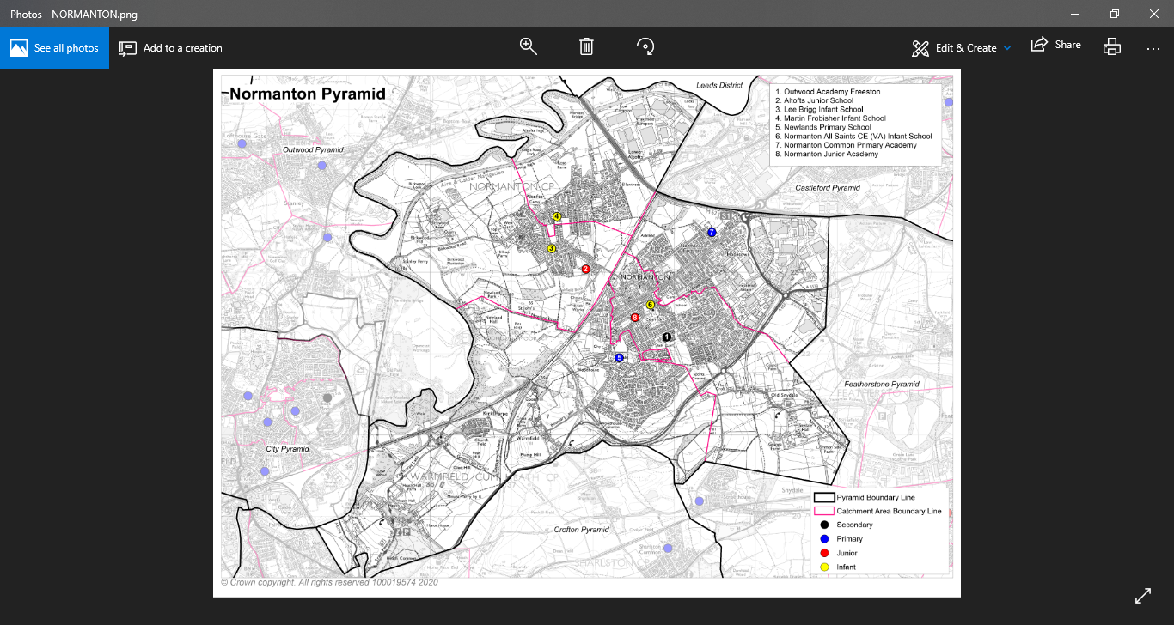
It is not possible to represent the full detail of the catchment areas on this visual map. You can look up your individual address to check for catchment priority on Wakefield Council’s website https://www.wakefield.gov.uk/schools-and-children/schools/school-catchment-area-search

Ossett Pyramid

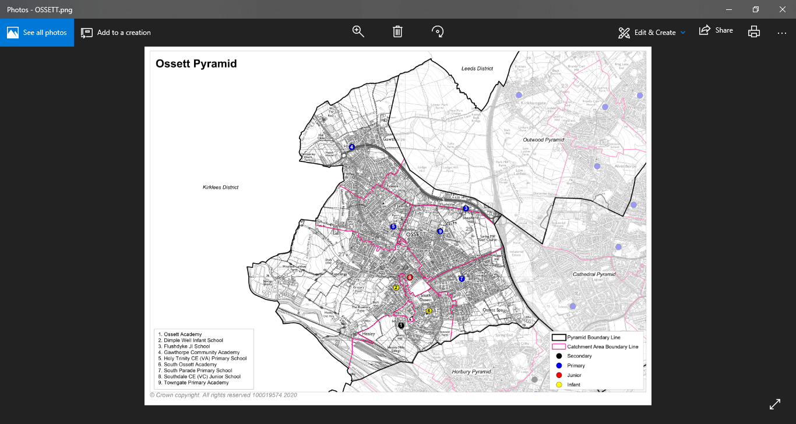

It is not possible to represent the full detail of the catchment areas on this visual map. You can look up your individual address to check for catchment priority on Wakefield Council’s website https://www.wakefield.gov.uk/schools-and-children/schools/school-catchment-area-search

Outwood Pyramid

